Esteban Andrade 12824583

Robotics  UTS

lab 1 aSSIGNMENT REPORT

Contents

1. WORKSPACE and ENVIRONMENT 2

2. Safety considerations 5

2.1 Safe work Method Statement 6

3. Reflection on UR3 6

4. USE OF MATLAB and Peter Corke’s Robotics toolbox. 7

5. Required Precision and Control methodologies. 8

6. Challenges of sensing and grasping 9

6.1 Sensing 9

6.2 Grasping 9

7. Movement safety 11

8. Computational efficiency 11

References 12

APPENDIX 13

# WORKSPACE & ENVIRONMENT

As described by universal robots the UR3 model is an excellent option for assistance in assembly processes, polishing, gluing, and screwing applications and used that may require uniformity in their product quality. It is mentioned that the manufacturer is the one that has power in the design of all the components of the robot. However, it does not have influence on how the robot is configured or assembled into a respective workspace and environment.

For the given application which was to take 9 standards bricks from different position and build a 3 by 3 wall. A UR3 as well as a linear UR5 will be used for this process, which involves that the corresponding robots will grasp a brick and place it in a final destiny position where the wall will be built. The process involves that both robots will be working simultaneously on the task to maximise efficiency. Refer to figure 1.

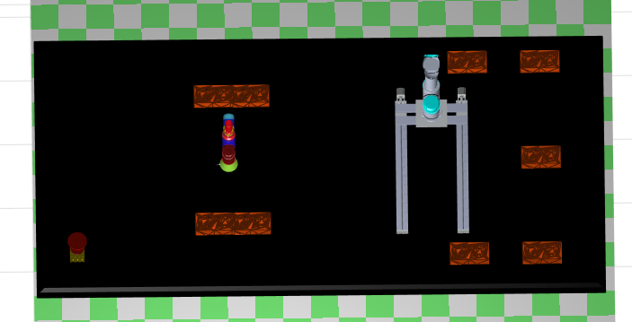

Figure 1: Top view of proposed workspace layout

The corresponding workspace and environment were designed in accordance with the dimensions of both robots considering safety and the given task. The location of the robots was considered using the respective reach of each arm in order to maximise capacity and to avoid any potential collision between both arms and the corresponding end-effectors.

Both robots will be mounted on top of a table, that has the capacity to fit both arms at full reach, and all the objects that are required to accomplish the task. Therefore, the dimension of the table will be sufficient to accommodate both robots with the respective safety distance and large enough to allow full rotation while allowing maximum transversal reach. The dimensions will be 4 m of long and 2 metres wide, with a total surface area of 8 m2. Additionally, it will have extra space to allocate the objects(bricks) around the corresponding robots and to undergo the task to build the wall in an assigned final position within this workspace.

The reason why both robots were mounted on top of a table was to avoid any wires or cables around the robots’ joints. Hence all the wiring and connections will be performed under need the table, as it will maximise and optimise the workspace usable space, while avoiding any potential damage to electrical connections that may cause serious damage to the equipment. There will be the corresponding mounts and wiring diagrams that will allow the operators to assemble both robots in different positions and orientation in this table. As a result, it will give great flexibility to the operators to assemble the robots to perform a wide variety of tasks. Furthermore, an emergency stop button will be located on the bottom left corner. This will allow to give the operators the option to have a mechanical switch that will allow to stop the robots and shut these down in case an unfortunate event may happen, and the need to shut both robots instantaneously arises. Refer to the image below.

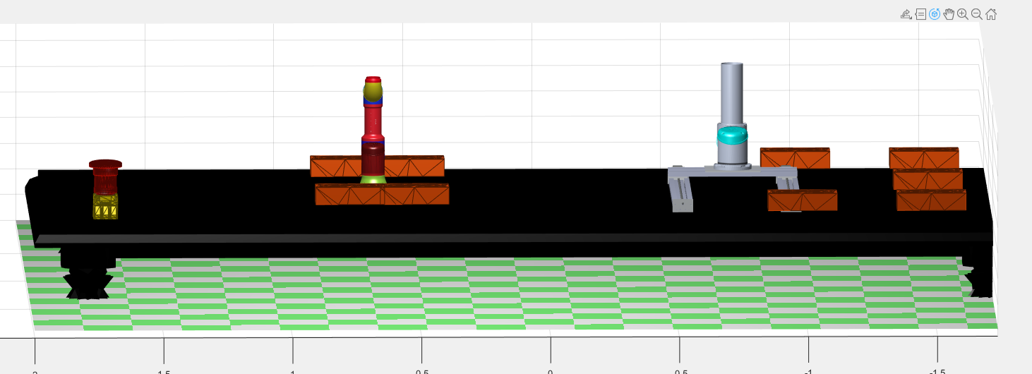

Figure 2: Side view of workspace

Furthermore, there will be a metallic cage that will surround the robots and the environment. Due to the collaborative nature of these robots it is necessary to have sufficient separation space between the robots and the cage. These fences will be made of metallic mesh and will provide visibility to the operator to successfully monitor the motion and operations of both arms. The fences will have a sliding mechanism that will allow them to be closed and open easily. Therefore, allowing to close the workspace once the robots are in motion to prevent accidents to the users and operators. Furthermore it will allow them to lock and store the robots in the same position overnight in order to improve security of the equipment and prevent any potential losses to components of the robots or the objects that are needed for the required task.

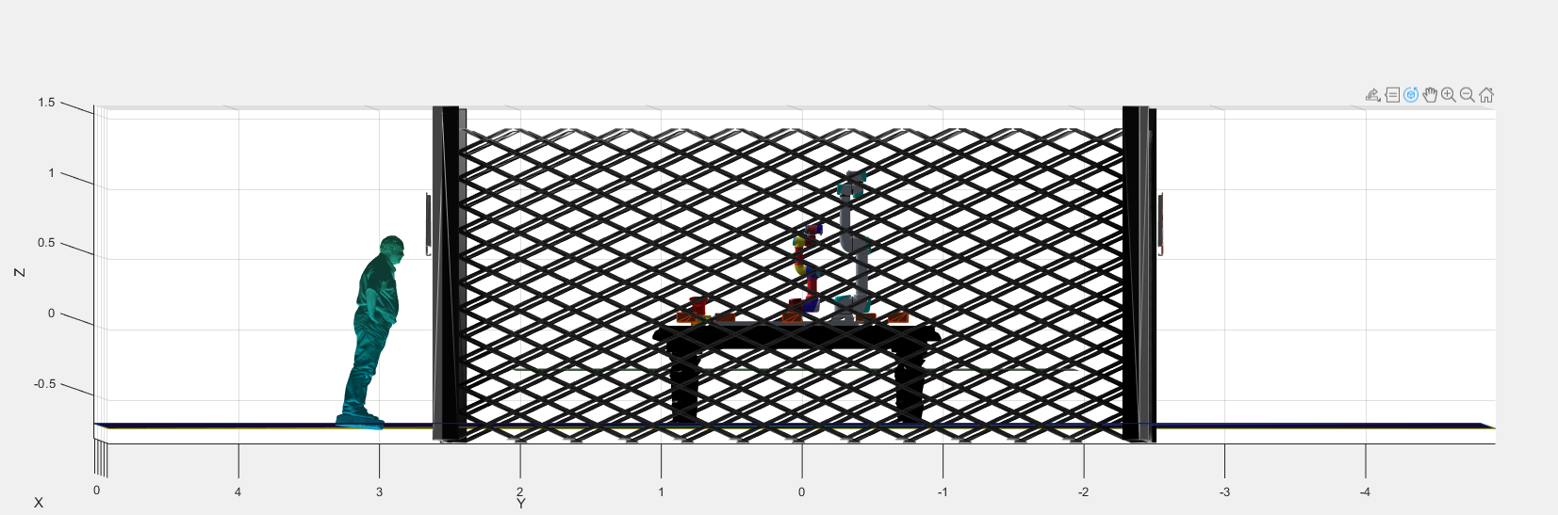

Figure 3: Side view with metallic cage

Similarly, there will be warning signs around the cage. With the intention to warn users and operators once the robots are in motion and operation. Hence, increasing the overall level of safety for all the users and operators.

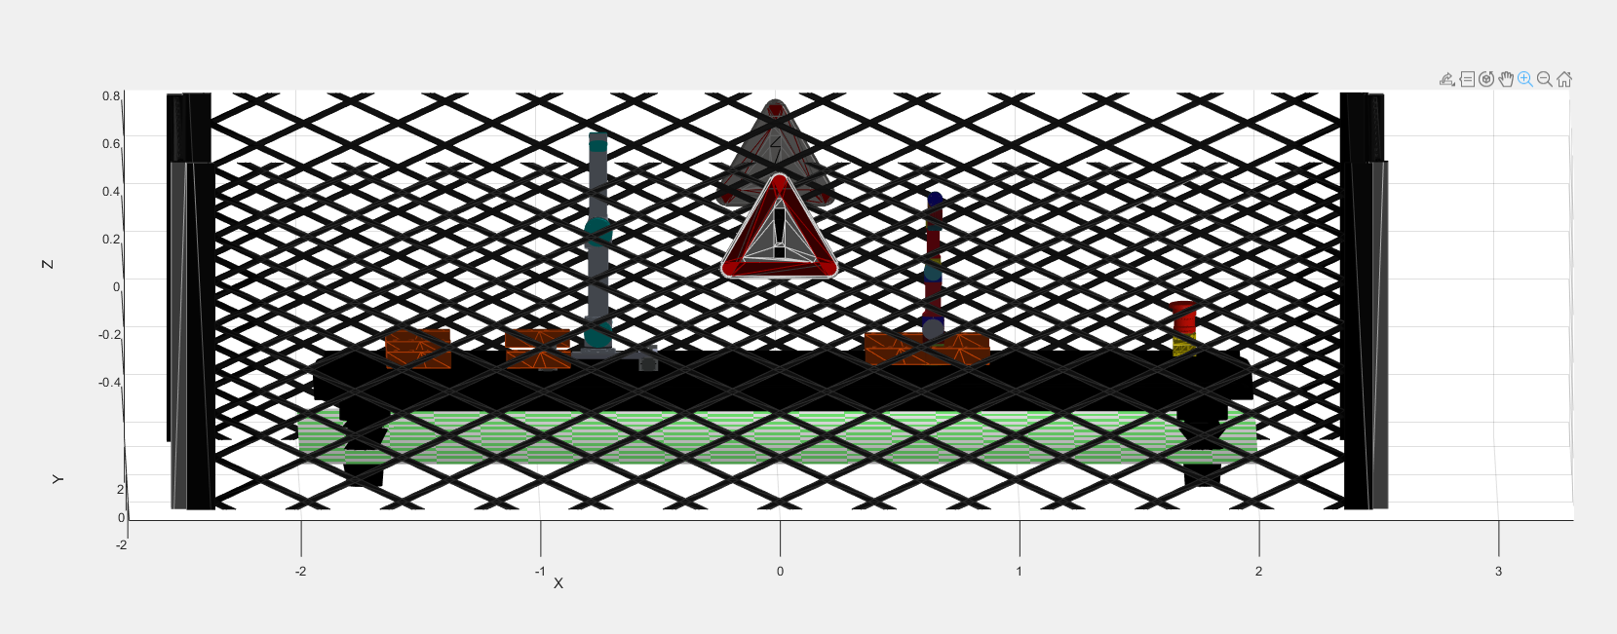

Figure 4: Warning signs for Workspace

The proposed and ideal layout for the components for the given task is described in the image below. The location of the wall at the end will be in the middle of the table. The proposed origin of the workspace will be the middle of the table, which will be the place where the final wall will be. Therefore, this will be position (x, y) to be (0,0). And all the other components will need to be in reference to this coordinate frame. Refer to image below.

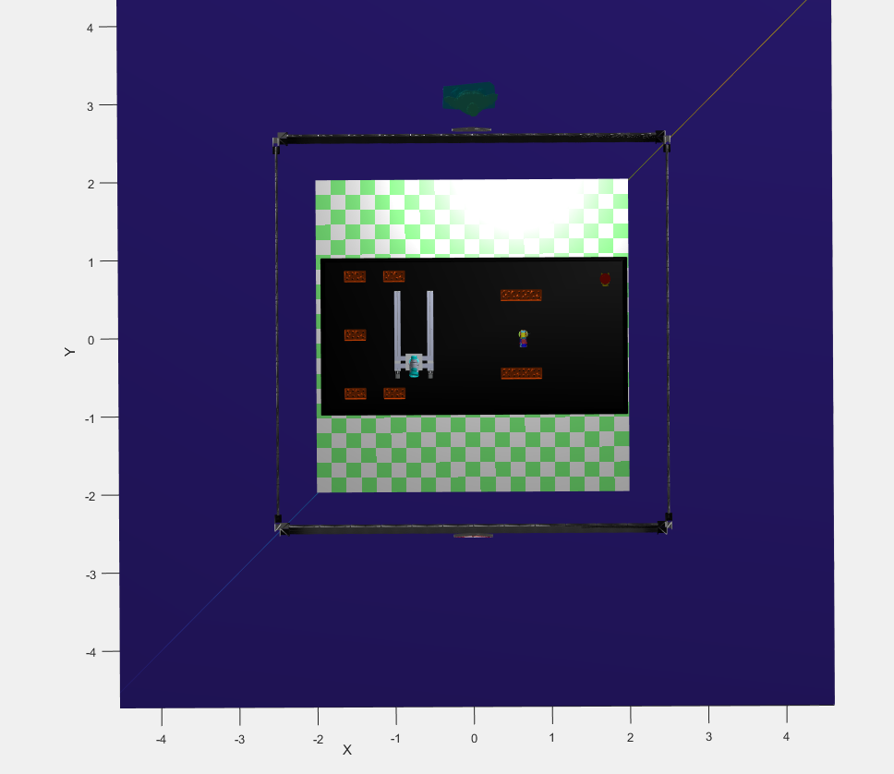

Figure 5: Top view of proposed workspace layout in space

List of all workspace components in reference to the coordinate frame:

* *Location of UR3:* The proposed location of the UR3 base will be 0.65 m to the left of the final position of the wall. Two offsets will be added to the DH parameters. These will be applied to links 2 and 4. The offsets are -pi/2 radians. The reason behind these was to make the arm upright therefore reducing the mounting effort. Furthermore, the joint limit of joint 2 must be constrained to -90 to 90 degrees. This will avoid possible collisions with the table.
  + Hence UR3 in the workspace will be on (0.65,0).
* *Locations of Linear UR5*: The proposed position of the Linear UR5 will be on 0.75 m to the right of the final position of the wall that needs to be built. The links will be centred in the table and the base will be offset to 0.35 m. Also, the arm will be up right to facilitate the mounting process.
  + Hence the UR5 position in the workspace will be (-0.75, -0.35)
* *The 9 bricks ideally will be position around the UR3 and the UR5.* The proposed position will be:
  + Brick 1 (0.5, -0.5)
  + Brick 2 (0.5, 0.5)
  + Brick 3 (0.75, 0.5)
  + Brick 4 (0.75, -0.5)
  + Brick 5 (-1, -0.75)
  + Brick 6 (-1, 0.75)
  + Brick 7 (-1.5, -0.75)
  + Brick 8 (-1.5, 0.75)
  + Brick 9 (-1.5, 0)

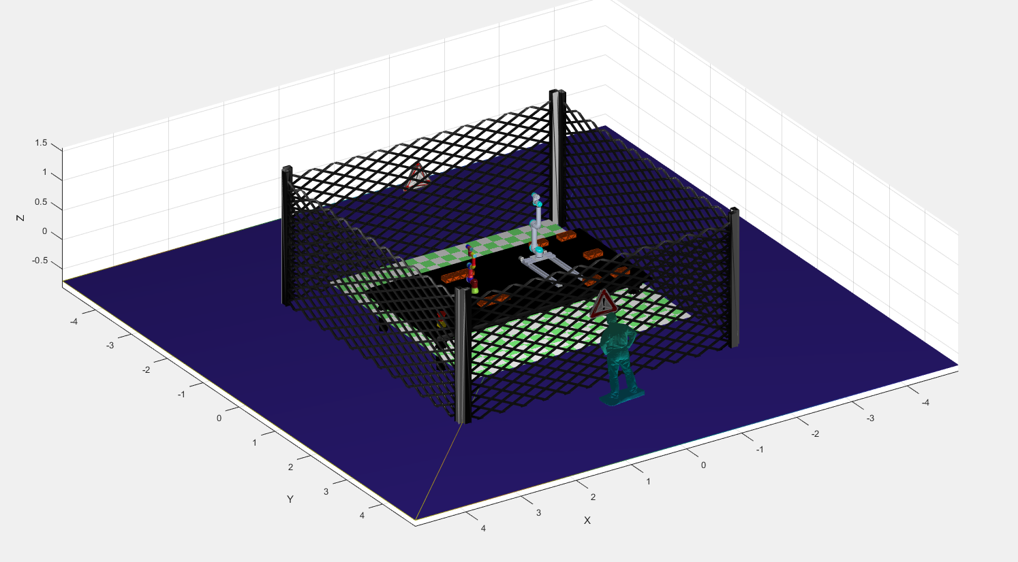

Figure 6: Isometric view of constructed workspace

# Safety considerations

The proposed workspace was design taking safety as a priority. The risks and hazards are classified based on the final risk (residual risk) that they possess after specific control measures are implemented in the workspace. Different safety measurements were implemented in the workspace with the intention to minimise the inherent risk to the operators.

These measures include:

* Installing the robots on top of a table in order to avoid electrical damages to the wiring. Also, to avoid any potential trip hazard.
* Installing an emergency stop button. To allow to stop the operation of the robots, in scenario that could include:
  + Possible Arms collision.
  + Incorrect assembly of wall
  + Malfunctioning of the robots.
* Installing a fence surrounding the robot with the intention to constrain the work area.
* Installing warning signs to mention that the robots are in operation.

As both UR3 and Linear UR5 are relatively lightweight, posses’ external sensors, rounded edges and controlled force and speed on the joints, they facilitate the collaboration process with humans for different applications. Although, these robots allow a great level of collaboration they still present a hazard to the users. Even if the risk level is low, there is the need to reduce as much as possible the hazards to the users by taking control measures for the workspace like the ones mentioned above.

Internal algorithms included for both UR3 and UR5 will aid to avoid possible self-collisions or collision with the other arm. Both robots will have to be properly setup and be able to communicate between each other using the corresponding ROS Nodes in order to track the ellipsoids around the links and avoid entering the ellipsoid volume of other links.

The risk assessment is available the Appendix.

All the risks were classified after the corresponding safety protocols and measures were implemented. These were organised according to their likelihood and the consequence level using a risk matrix shown in the image below. These risks will be classified from low to critical.

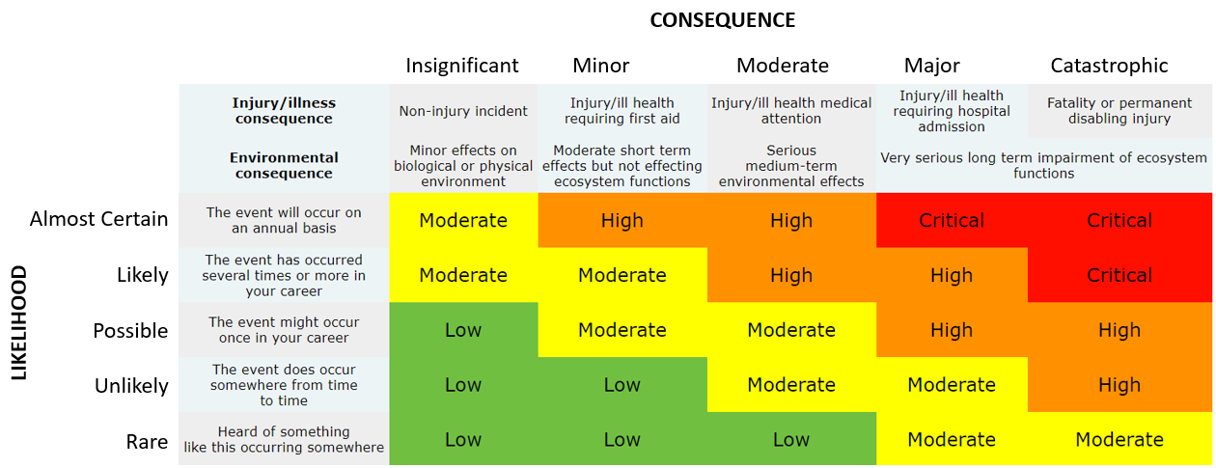

Figure 7: Risks matrix

## 2.1 Safe work Method Statement

A proposed safe work method is included on the appendix. It will provide enough information for the corresponding activity that is associated in controlling both UR3 and Linear UR5. The proposed safety measures and protocols for the given task, building a wall, are included as well.

# Reflection on UR3

The UR3 robot from universal robots is an optimal assistant used in different applications that range from manufacturing industries to medical devices to electrical assemblies. Nevertheless, it is not a perfect tool and it offers certain limitations. For this particular application the UR3 is an adequate option as it provides and simple and fast installation. It has a total weight of 11kg (24.3 lb). Its compact and relatively reduced weight allows it to be stored and moved around the workspace easily and to be switched to different environment to be used in different applications.

With the option to constrain the joint and force limits, the task can be design in accordance to the environment and the object to be moved. With the nature of the UR3 of having 6 axis, making it a collaborative tabletop robot with 6 degrees of freedom. It will allow to move the end-effector to any 3D point that is in range of its maximum reach of 500mm while maintaining any possible orientation. Therefore, it gives the capability of the robot to have almost infinite possible wrist rotations and with a repeatability of +/- 0.1 mm makes the UR3 and excellent option for grasping and handling different objects.

On the other side, one of the limitations for the UR3 would be it reduce ability to collect heavy objects, as its maximum payload is estimated to be 3 kg. Nevertheless, for the given application the UR3 would be suitable to pick all bricks, as the standard brick weight is around 2.5 kg. The linear UR5 would be more suitable to grasp much heavier bricks. The cost of a UR3, with out a grasping or gripping attachment mechanism is estimated to be 36000 $ USD. If there was the need to include sensors or grippers the estimated prices will spike to approximately 55000$ USD.

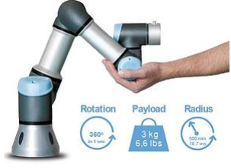

Figure 8: UR3

Finally, the incredible benefits of the UR3 that include the 6DoF implementation, ease installation and assembly it can be used for many applications. It will reduce the overall labours costs and increase production rates as this piece of equipment could work for extended periods of time.

# Use of MATLAB and Peter Corke’s Robotics toolbox.

The use of MATLAB simplified many of the programming concepts that may be required to control the robots such as object-oriented programming and possible physics simulator like gazebo. One of the main features of using MATLAB was the easy to import ply files that will allow to model the environment and the UR3 model. Furthermore, MATLAB simplifies the process on how to model each component of the workspace in each corresponding position and orientation.

Similarly, MATLAB allows to run specific sections at of the code at ease, rather than running all the script, which provides great flexibility on how to run parts of the code.

Additionally, Peter Corke’s Robotics toolbox provided skeleton code that allowes easily association of different classes for the UR3 and to incorporate the corresponding plyfiles to model the links. Furthermore, it allowed to perform mathematical analysis of both forward and inverse kinematics of the joints that would allow to get the corresponding poses of the end effector, and the links configuration in different poses. Thus, it saved an incredible amount of time, that in order circumstances might have been spent on building a library from scratch that would execute the same calculations. With aid of fkine from the robotics toolbox we can get the pose of the end effector for both robots in different locations.

Regarding inverse kinematics the use of ikcon create a more precise result and reduced the error in the calculation in comparison with ikine, therefore in creating the final q matrix of joint limits. The robotics toolbox allowed to use different methods and functions that would allow to calculate both forward and inverse kinematics. Thus, allowing a great level of flexibility for the mathematical analysis, as this was embedded and associated with the UR3 self-made class.

With standard classes for both UR5 and UR10 the UR3 class was relatively easy to create. It allowed to modify the DH parameters easily, also giving access to different parameters such as qlims, models, base, etc.

On the other side, MATLAB struggled in the animation process and importing the plyfiles into the environment. Therefore, there was a significant amount of time spent in rendering the environment and set it up for the given task. Although MATLAB provides easy and quick implementation for functions and classes, it lacks the best features of a regular programming language such as C++ or python. This is clear on how MATLAB manages classes and data structures. Also, MATLAB lacks the ability to implement threading and synchronization that would have made the execution process smoother and less computational demanding.

Despite all the benefits that the robotics toolbox provides, it does not provide any sort of collision checking feature. The use of the MATLAB MathWorks Robotics System Toolbox or Native ROS would have offered this feature instead. The use of ROS would have been beneficial as it provides more technical detail for both simulations in environments such as rviz or gazebo.

# Required Precision and Control methodologies.

For the required simulation one of the assumptions was that there is no specific detail on how the gripping and joint parts should move in order to grasp and collect the bricks. Nevertheless, in a real-world scenario, this would play a very crucial and important role. As there must be a great level of attention that should be put on controlling the joints movement and forces as well as how the gripper will grasp the bricks and place then in the final position.

The order and control on how both robots will collect the bricks and place them in the final position must be exact, as any potential miscalculation could cause a collision. Therefore, there must be great level of synchronization between both robots, as well as controlling the movements of the bricks to the final position to build the target wall.

As mentioned before the UR3 has a +/- 0.1 mm repeatability which provides accurate movement that would allow great level of control that would meet the requires specification.

With an autonomous approach, both robots should be controlled using sensors and cameras for visual servoing of the arm. This would allow to have feedback information extracted and allow to have a more accurate control motion of the arm. The depth images captured from the camera will be process using a ROS node and sent back to the arm to plan its trajectory accordingly. Path planning will check the environment and generate a valid path that will avoid any potential table or objects collisions. Similarly, inside the same node there will be an algorithm that will check for any potential self-collision between links that will be integrated with the corresponding path planning node. In order to increase efficiency, both robots will send the corresponding poses and projected trajectories in order to avoid any potential collision. If any collision is predicted the path will adjust itself for both robots.

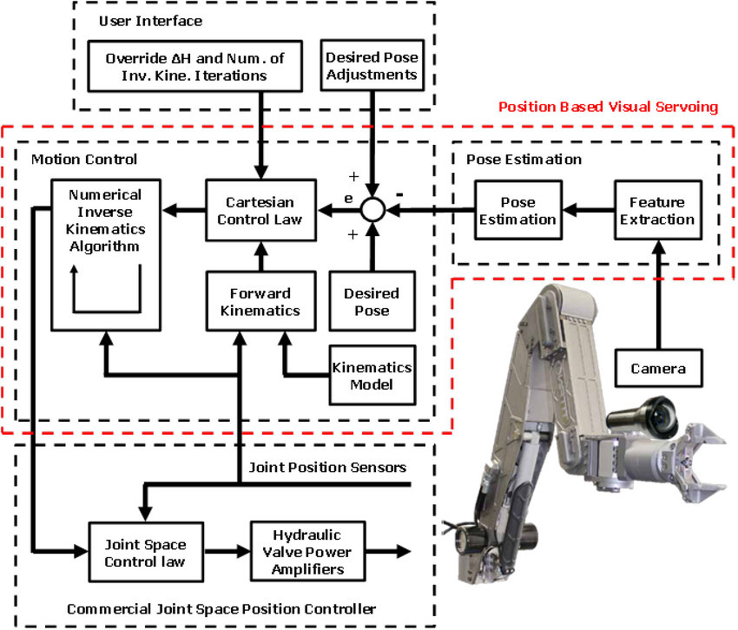

Figure 9: Robot arm Visual Servoing

# Challenges of sensing and grasping

Regarding sensing and grasping there are many challenges that would have been encountered to carry out this task. Multiple sensors would need to be integrated to fully sense the environment and gather data. Physical testing would have been required in order to ensure an accurate mechanism for grasping the bricks.

## 6.1 Sensing

For an autonomous approach both UR3 and UR5 will not any predefined path that could require precise locations of the corresponding objects. Visual Sensors would improve the efficiency of the process and safety around the workspace, as it will give a great level of automation and accuracy for the given task. Computer vision sensors such as an Intel RealSense D435i would allow to check that all components are correctly positioned and orientated in the final position. The depth images and RGB data would allow to fully detect the objects and send data to the arm for the path planning movements. The depth images and RGB images will generate the corresponding point clouds of the environment that would be used to detects and generate the corresponding path planning to grasp the object and place them in the final position.

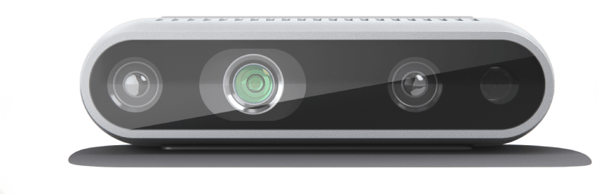

Figure 10: Intel Realsense D435i

The corresponding sorting algorithm along with the camera will allow to get the location of the object in it final pose and from this the Robotics toolbox would be used to obtain both forward and inverse kinematics that would allow to control the movements.

## 6.2 Grasping

Grasping objects is always challenging for any applications. In this particular case the end-effector has to be attached with a suitable gripper that would be able to fully grasp a standard brick without losing any grip whatsoever. The objects shapes, sizes, weight, and materials always represent a challenge for grasping objects. In this example the gripper must be able to collect standard square bricks of around 2.5 kg each one.

As mentioned before, both robots should operate autonomously and to be controlled dynamically with the acquired environment data. Both UR3 and Linear UR5 would require having the same gripper in order to make the process uniform. A potential gripper will be a 2-finger gripper similar below image. The main advantage of this gripper is that it is used in many industrial applications that involve pressure control, opening control, distance control in the opening and closing, picking pieces up and locate them in other locations in space. Thus, would facilitate the process of collecting square bricks and position them in the corresponding location to build the wall. Ideally all the bricks should be collected from the top, with the finger’s components on the side of the brick.

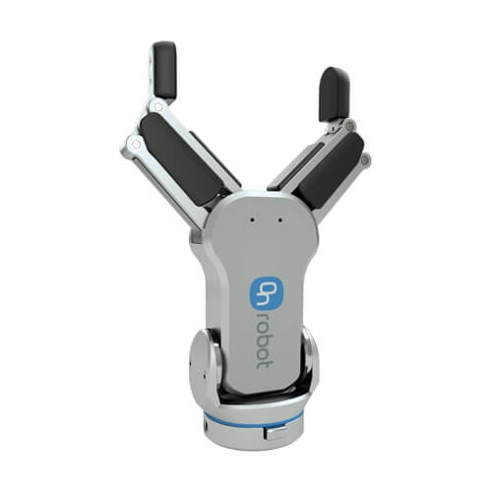

Figure 11: two finger gripper

The proposed way to grasp the bricks will be to use the two-gripper grasp tool and grip both lateral sides of the brick to collect them. See images below.

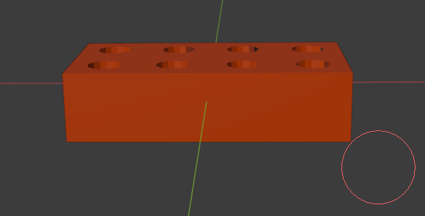



Figure 12: Way to grasp bricks side view

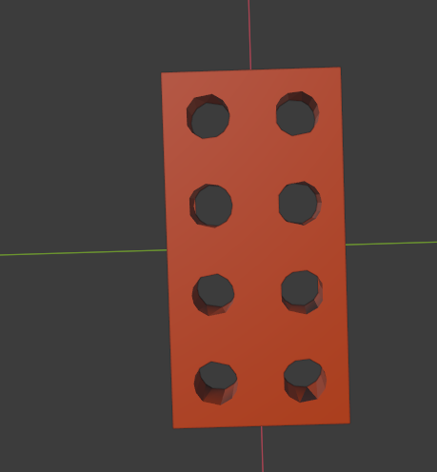



Figure 11: Way to grasp brick. Top view

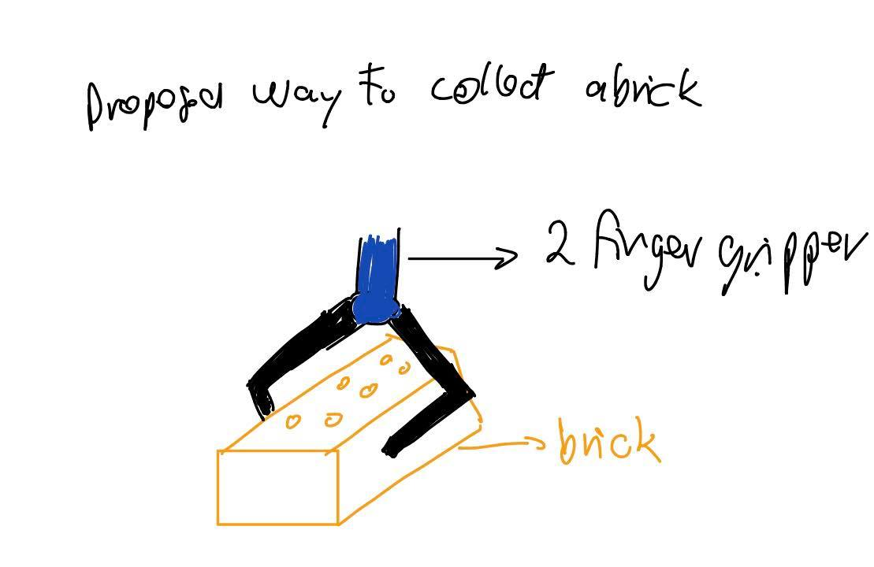

Figure 12: Proposed way to collect brick

# Movement safety

Regarding motion for both UR3 and Linear UR5, safety motion plays a crucial role. It is a must to simulate the motion operation beforehand, as this would allow to have an illustration of how the robots will behave and accomplish the given task. Due to the expensive nature of this robots it is ideal to ensure that there will be no physical damage to the equipment itself or any operator. Hence, Simulations would allow to simulate the motion before the script is tested on the real robots. As mentioned by Vargas (2018) safety of all objects and humans in and around the environment must be fully guaranteed beforehand. With the embedded algorithms used for self and object collision detection the path planning will be generated considering safety of the equipment itself and operators that may be around. Hence reducing the risk of injuring a worker or damaging the equipment.

Similarly force limits should be constrain in order to protect the workers and the robot and potential joint in case any potential impact forces may appear in the joints.

# Computational efficiency

Looking at appendix and from the MATLAB profile tool, it comes evident that a significant amount of time is spent on the modelling and rendering of the objects for the environment. Therefore, importing the plyfiles into the environment will take a significant amount of time for the entire simulations. On another note, this time will vary depending on the operating system, as lighter OS’s such the ones based on UNIX or Linux will use less computational resources in comparison to windows.

One of the main functions that took a significant amount of time was the controller part of the UR3.This function main purpose was to animate the motion of the links, and it had 2226 calls for the entire script. This will use a significant amount of object resources as it will render the new updated links in different position for the trajectories.

Created members functions from the class Robot motion used for double motion what will generate both motion q matrixes for the UR3 and UR5, take around 7 seconds to be generated given 50 iterations. Which is a reasonable amount of time. However, it can be improved by reducing the number of steps for the iteration analysis.

Similarly, one possible way to reduce the rendering time it would be to reduce the vertices count for all the object plyfiles. Thus, it will take less loading time and speeding up the process.

# References

Anon, 2020, S3-eu-west-1.amazonaws.com. viewed 6 September 2020, <https://s3-eu-west-1.amazonaws.com/ur-support-site/16336/100403.PDF>.

Bélanger-Barrette, M. 2020, *Universal Robots Releases UR3*, Blog.robotiq.com. viewed 6 September 2020, <https://blog.robotiq.com/universal-robots-releases-ur3>.

Ruiz 2020, *Robot Grippers: Types and Applications in the Industry*, Ennomotive. viewed 6 September 2020, <https://www.ennomotive.com/robot-grippers-industrial-applications/>.

UR3e collaborative table-top robot arm that automates almost anything 2020, Universal-robots.com. viewed 6 September 2020, <https://www.universal-robots.com/products/ur3-robot/>.

UR launches UR3 most flexible, light-weigt table-top 2020, Universal-robots.com. viewed 6 September 2020, <https://www.universal-robots.com/about-universal-robots/news-centre/universal-robots-launches-ur3/#:~:text=%E2%80%9CUR3%20is%20an%20optimal%20assistant,parts%20in%20optimized%20production%20flows>.

Vargas, S. 2018, *Robots in the workplace*, Safetyandhealthmagazine.com. viewed 6 September 2020, <https://www.safetyandhealthmagazine.com/articles/16789-robots-in-the-workplace>.

# APPENDIX

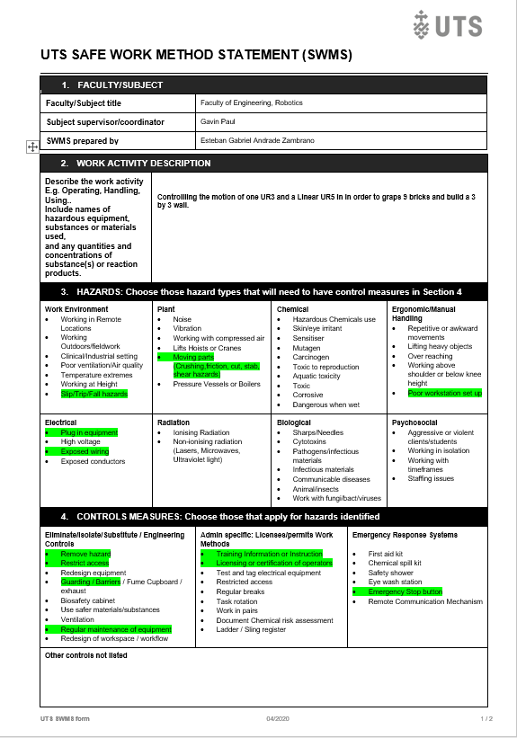

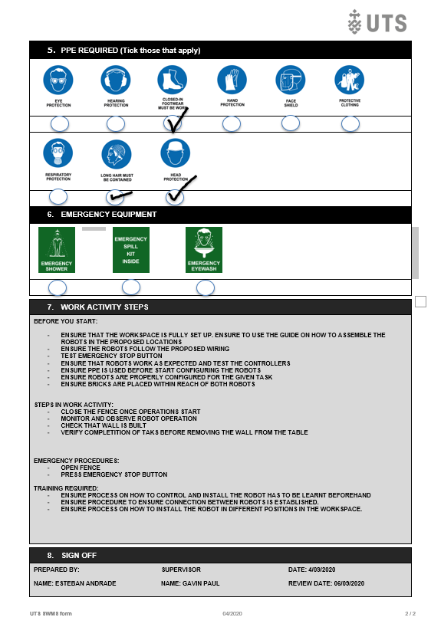

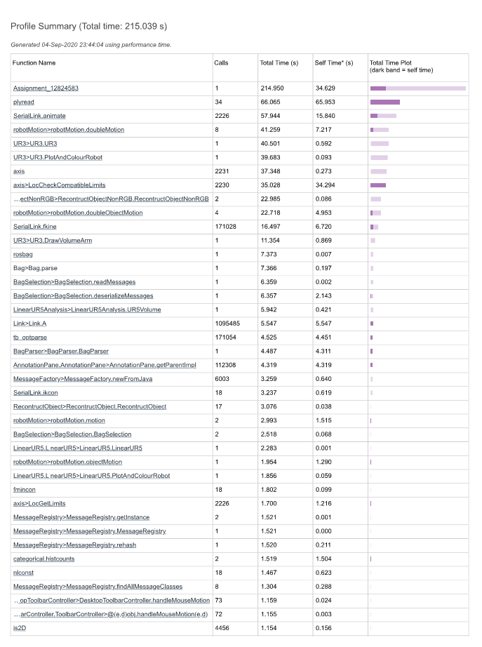

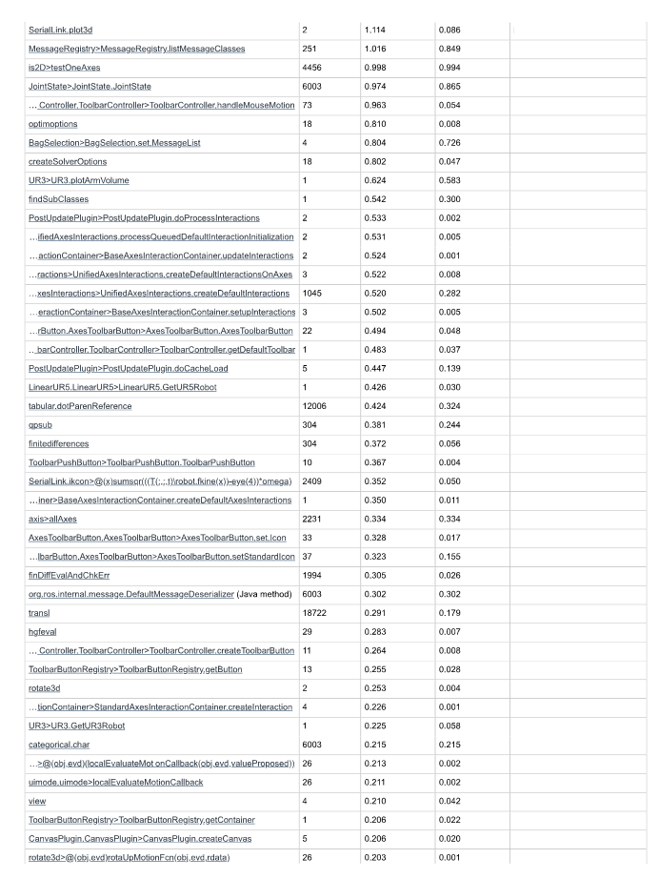

**GENERAL RISK ASSESSMENT**

|  |  |  |  |  |  |
| --- | --- | --- | --- | --- | --- |
| **Work area / operation** | 3x3 brick wall building process | **Assessors name** | Esteban Andrade | | |
| **Other persons consulted** | Gavin Paul | | | **Date** | 6/09/2020 |

|  |  |  |  |  |
| --- | --- | --- | --- | --- |
| **ACTIVITY**  - Describe hazardous activities related to the work area or operation. | **ASSOCIATED HAZARDS** | **INHERENT RISK**  - Harm that could happen is measures are not in place | **PROPOSED CONTROL MEASURES**  - Proposed action to minimise risk to a manageable level | **RESIDUAL RISK LEVEL**  - Likelihood  - Consequence  - Risk Level |
| Moving robotics arms and bricks | Arms to arm collision, end-effectors collision,  Self-arm collision | Broken or damaged robots and its components. | Proper software integrated for the robots in order to prevent self-collision and collision with another robot | - Possible  - Minor  - Low |
| Moving robotics arms and bricks | Collision with operators | Injury and damage to operators. Damage to equipment | Metallic fencing cage and warning signs for the workspace | - Unlikely  - Minor  - Low |
| Power Robotics arms | Power and electricity | Hight current and voltage  Short circuit | Ensure electrical wiring is safe. No liquids or other objects that may affect the components | - Unlikely  - Major  - Moderate |
| Power Robotics arms | Wiring and cabling | Tripping operators.  Damage to cables  Short circuit | Electrical wires setup under the table | - Unlikely  - Minor  - Low |
| Brick detection | End-effector collision,  End-effector to brick collision | broken or damaged end-effectors and robot components | Emergency stop button | - Possible  - Minor  - Low |

|  |  |  |  |  |  |  |
| --- | --- | --- | --- | --- | --- | --- |
| **Supervisor approval of assessment** | | I am satisfied that the residual risk with existing controls is acceptable ☐Yes ☐No  OR  I am satisfied that that the proposed controls will reduce risk to an acceptable level. ☐Yes ☐No | | | | |
| Supervisors Name | Gavin Paul | | Signature | Gavin Paul | Date | 6/09/2020 |